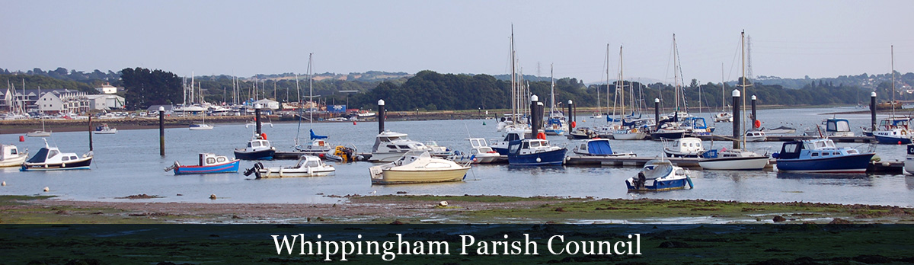

**WHIPPINGHAM PARISH COUNCIL**

**NOTICE OF VACANCY IN OFFICE OF PARISH COUNCILLOR**

**ARE YOU COMMUNITY MINDED? DO YOU WANT TO BE INVOLVED   
IN YOUR COMMUNITY?**

**A Vacancy in the South Ward has arisen for a Councillor to be**

**co-opted onto our Council.**

**The Council is asking for nominations to fill the vacancy.**

**If you are interested your name must appear on the current register of Voters List or the applicant should during the whole of the 12 months preceding the relevant date have**

**resided in or within three miles of the Parish or the applicants only place of work during then whole of the 12 months preceding the relevant date is in the Parish. The applicant must not be debarred from standing as a Councillor.**

**If you are interested and would like to be considered, please put forward your name together with a description of what you have done, what can you offer the Council, what your interest are and why you would like to be considered to become a Parish Councillor.**

**If you would like to talk about what is the role of a Parish Councillor or want any further information, please phone the Parish Clerk on 852576.**

**Expressions of interest to be with the Clerk by mid-day on the 31st May 2025**

**Addressed to Valerie Taylor, Parish Clerk**

**3 Downside, Ventnor, Isle of Wight PO38 1AL**

**or by email to whippinghamclerk@gmail.com**

**After which Interviews for the candidates will then be arranged.**

**DATED** **this 8th MAY 2025**

**Valerie Taylor**(  
Signed) Valerie Taylor Parish Clerk