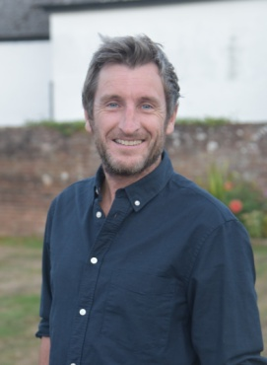 **Cllr Matt Price**

***Annual Report for the Annual Meeting of Whippingham Parish Council 2024***

**Matthew Price IOW Councillor for Fairlee & Whippingham**

I very proudly continue to represent the residents of Fairlee & Whippingham on both Newport & Carisbrooke Community Council, Whippingham Parish Council and the IOW Council for 2023 and into 2024.

**Roads, Pavements, Footpaths and Drainage:** The flooding issue in Howard Close which also affects residents in Victoria Road is a huge concern, I have had multiple meetings with Southern Water, Island Roads, the housing association and the IOW council regarding this issue and there seem s to be no doubt that the issue rests with Southern Water. Recent works have taken place but unfortunately we will not know if this issue is resolved until the next time we are faced with torrential rain. I will not stop pursuing this issue until a permanent solution is found. Southern Water are closely looking at this and I am desperately trying to get them to move this up their priority list.

We also had the culvert blocked under Cross Lane which cased the road to flood. I attended this myself and cleared the culvert and stream, ore regular maintenance to the side of stream is required.

**Planning:** I have been working on opposition to several planning applications and although i was unable to prevent the development on Staplers Road (behind Heath Close from going ahead, I was able to secure many condition which includes moving the telegraph pole which partially blocks the pavement on Staplers as part of the approval.

I continue to work towards opposing the second attempt to develope the field in landscape lane. This is an entirely inappropriate development which will irreversibly damage the ‘rural feel’ of this lane and would jeopardise the viability of the farm land.

I have now been a member of the IOW Councils planning committee for over 11 years I have seen off several planning applications within the ward and will continue to represent the community as new applications progress or come forward. I have a track record at supporting planning applications where appropriate and work hard to make sure the poor or inappropriate ones are either refused or controlled with strict conditions. The island Plan is likely to be voted on by the IOW Council in May and if successful the allocation of 880 houses at fairlead Farm will be removed once and for all. I campaigned hard to have this huge parcel of land removed which was included within the last review, this area at New Fairlee Farm which had an allocation for 880 houses and I have successfully had removed in is entirety.

**Festivals in Newport:**

The IOW Festival continues again this year as usual in June. Although the festival organiser will again handle the barrier controls on Staplers again this year but with much better handover procedures between shifts, Last year there were some issues with different shifts taking different approaches to the management of the barriers. I am also assured that the noise levels will not exceed the level allowed as they did the year before last at several times.

Also residents will be pleased to know that the cabin will again return to Harvey Road for the Permit system.

I once again thank residents for their patience during the disruption that the festival causes

**Newport Football Club**

We have yet again missed another milestone in regards to the construction of Newport Football Club and myself and my adjacent Councillors continue to put pressure on the developer to ensure this finally gets built.

**Cycling and pedestrian shared route upgrade.**

As reported last year there was a large infrastructure upgrade to the pedestrian route from the Riverside Centre, through the Fairlee Tunnel and through to Mews Lane. This has seen an incredible improvement and makes this route much easier to use all year round and much safer.

The cycle routes around the Island are so very important and I am always looking at way they could be added to. As you will know cyclists and pedestrians currently then have to come out onto Fairlee Road until almost the Racecourse roundabout due to land that is not currently under ownership of the council. I mentioned in my previous reports that one section had been gifted to the IOW Council and I hope that other sections of the route may be secured for use in the future through planning applications to complete this route all the way through to Wootton.

**Gravel Extraction**

The long expected aplication for gravel extraction in Wootton has still not come forward. I am working hard to ensure the site traffic does not take an agreed route in both directions and will work hard to ewnsure the approriate decision that may affacet residents is taken.

**Other news:**

Unfortunately the controlled junction, crossing and pavements to the junction of Mill Lane and Fairlee Road have hit another obstacle.. The developer/owner of Island Harbour continues to be in administration. This has meant the Breeze restaurant has remained closed and much uncertainty exists. there. Hopefully a new owner can be found who will actually see through the final stages of the development and see good the promises that have been made via the previous planning approvals. I will be resisting any further development at Island harbour until the junction improvements take place and this dreadfully dangerous part of Fairlee Road.

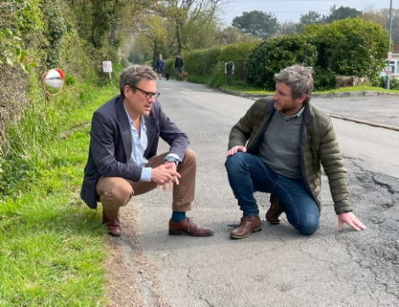 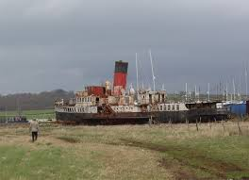 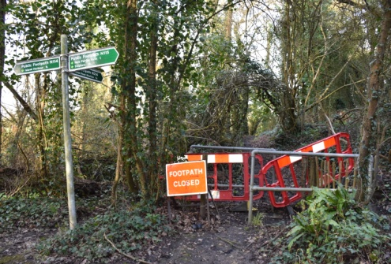

The Ryde Queen also still has an enforcement notice and should have been removed after all attempts to rescue the vessel failed. Sadly the boat must be removed as it now poses a potential environmental risk. It is still expected that the engines and many other parts of the vessel may be used in museums and education centres around the country.

I would like to thank Newport and Carisbrooke Community Council for all the work and support that has been given to the ward of Fairlee. Most importantly the continued support in subsidising the No39 Bus, which is a vital lifeline for local residents including the route to the newly announced doctors surgery on Riverway Industrial estate. NCCC also support various projects in and around the ward, including additional grounds maintenance, orphaned areas maintenance, dog bins and many other things.

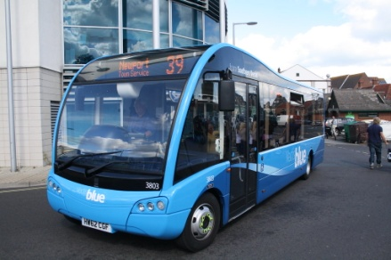

We understand that there are many residents of Whippingham who are affected by the surgery move from Wootton and colleagues in Newport are working with me to improve the 39 bus which currently leaves Newport bus station and has a stop near to the new surgery.

I have many roles within the local community and in addition to being your IOW Councillor, I am also a Councillor on Newport and Carisbrooke Community Council, I am also a Councillor on Whippingham Parish Council, I continue in my eleventh year as a member of the Planning Committee, and I am a member of the Harbour Committe, the Chairman of the Assets and Facilities Committee at NCCC, Heavily involved in Newports Heritage and formed the Newport & Carisbrooke Heritage Society. I am a Governor at Barton Primary School, I have been a long standing PTFA member at Shalfleet Primary, I am also a Trustee at Carisbrooke Castle Museum.

Please feel free to get in touch with me to discuss any issue that I may be able to help with.

Best wishes

**Matthew Price**

**07833 537 668 Mobile, 524320 (work)**

[matthewpriceisle of wight@gmail.com](mailto:matthewpriceisle%20of%20wight@gmail.com) or [Matthew.Price@iow.gov.uk](mailto:Matthew.Price@iow.gov.uk)

6 Whitesmith Road, Newport, Isle of Wight PO30 5HY